

**Research & Vehicle Technology**

**“Infotainment Systems Product Development”**

**Feature – EVSE**

**Infotainment Subsystem Part Specific Specification (SPSS)**

Version 1.0

**UNCONTROLLED COPY IF PRINTED**

**Version Date: August 22, 2022**

**FORD CONFIDENTIALF**

**Revision History**

|  |  |  |  |
| --- | --- | --- | --- |
| **Date** | **Version** | **Editor** | **Description** |
| **Feb 11, 2023** | **1.0** | [**xli244@ford.com**](mailto:xli244@ford.com) |  |

**Table of Contents**

Revision History 2

1 Overview 5

1.1 Feature Description 5

1.2 Library Calibration/Configuration file usage 5

2 Architectural Design 6

2.1 EVSE-SV-REQ-xxxxxx/IBD_ElectricEnhanceSoundSystem 6

2.2 EVSE Class Description 7

2.2.1 EVSE-CLD-REQ-xxxxxx/ NVH Event Server 7

2.2.2 EVSE-CLD-REQ-xxxxxx/NVH Event Client 7

2.2.3 EVSE-CLD-REQ-xxxxxx/BCM 7

2.2.4 EVSE-CLD-REQ-xxxxxx/EVSE Diagnostics server 7

2.2.5 EVSE-CLD-REQ-xxxxxx/EVSE management 7

2.3 Interface Requirement 8

2.3.1 NVH event server to APIM_CIM 8

2.3.2 BCM to APIM_CIM 13

2.3.3 DSP to APIM_CIM 13

2.3.4 APIM_CIM send(Reserved) 15

3 General Requirements 17

3.1 EVSE-SR-REQ-xxxxxx/Feature Enable Configuration 17

3.2 EVSE-SR-REQ-xxxxxx/Tuning Profile Configuration 17

3.3 EVSE-SR-REQ-xxxxxx/Tuning file Configuration for Drive Mode 17

3.4 EVSE-SR-REQ-xxxxxx/EVSE DTC 18

3.5 EVSE-SR-REQ-xxxxxx/ DID-Internal Error 18

3.6 EVSE-SR-REQ-xxxxxx/EVSE Settings 19

3.7 EVSE-SR-REQ-xxxxxx/EVSE Enhanced Memory 19

3.8 EVSE-SR-REQ-xxxxxx/EVSE Audio Path 19

4 Functional Requirements 20

4.1 EVSE-SR-REQ-xxxxxx/EVSE Calibration File Structure 20

4.2 EVSE-FUN-REQ-xxxxxx/EVSE Power Mode 20

4.2.1 Functional Requirements 20

4.2.2 Use Case 20

4.2.3 EVSE-SD-REQ-xxxxxx/EVSE Startup Sequence Diagram 21

4.3 EVSE-FUN-REQ-xxxxxx/EVSE Error Handling 21

4.3.1 Functional Requirement 21

4.3.2 Use Case 22

4.4 EVSE-FUN-REQ-xxxxxx/EVSE Enable/Disable by user 24

4.4.1 EVSE-SR-REQ-xxxxxx/EVSE Audio Enable/Disable 24

4.4.2 Use Case 24

4.4.3 Activity Diagram 25

4.4.4 Sequence Diagram 26

# Overview

## Feature Description

The term ’Electric Vehicle Sound Enhancement’(‘EVSE’) refers to the vehicle’s feature to add more complex non-combustive sound elements for enhancement of hybrid and full electric vehicle propulsion sound. This specification only applicable for SYNC+ integrated EVSE.

## Library Calibration/Configuration file usage

The acoustic calibration “file” used for EVSE feature is unique to a specific vehicle model ,which is effected by speakers layout or powertrain module. Generally, calibration parameter also unique to a specific drive mode. All of this can be realize through DExx configurations.

# Architectural Design

## EVSE-SV-REQ-xxxxxx/IBD_ElectricEnhanceSoundSystem

Audio system without DSP:

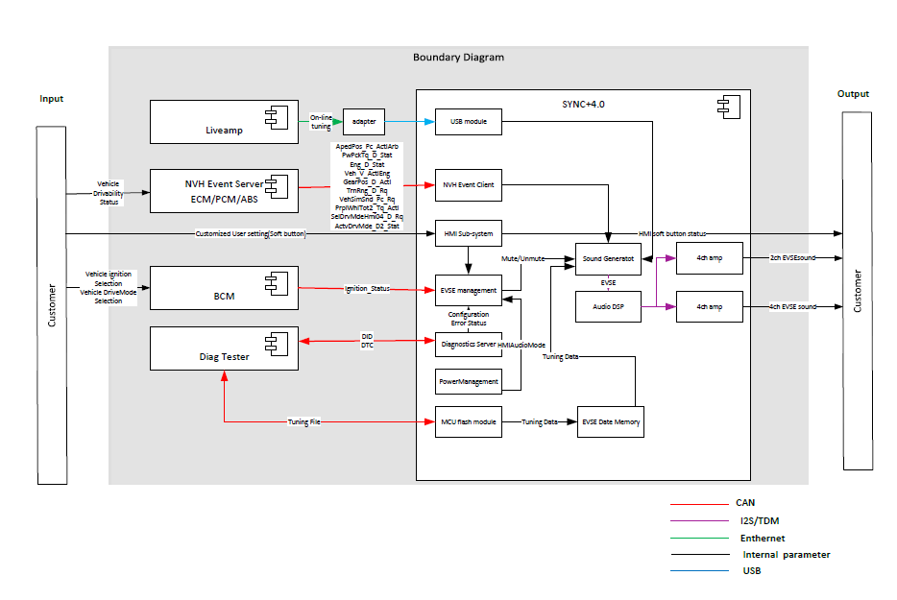

Audio system with DSP:

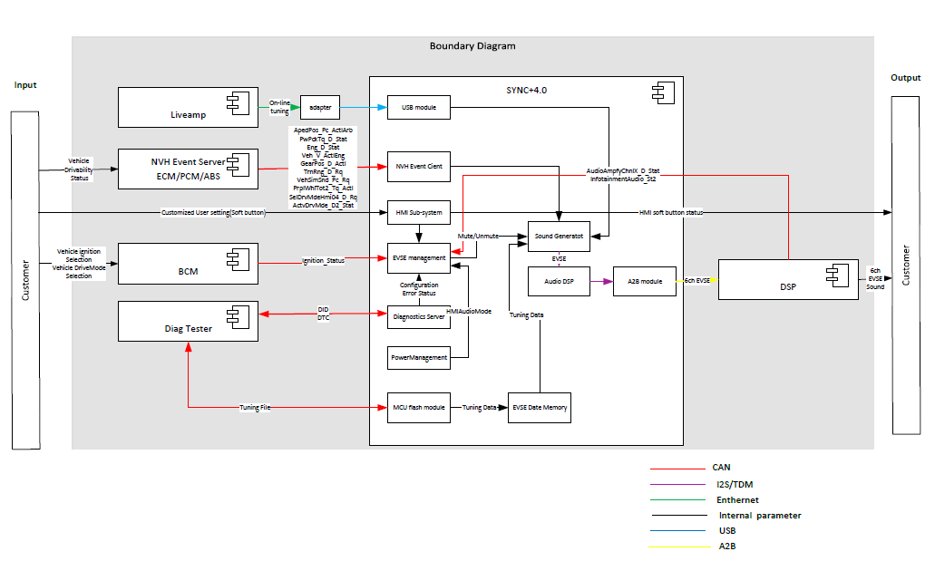

## EVSE Class Description

### EVSE-CLD-REQ-xxxxxx/ NVH Event Server

The ‘NVH Event Server’ is responsible to notify the change in drivability status. Interfaces is used by EVSE sound tuning.

### EVSE-CLD-REQ-xxxxxx/NVH Event Client

The ‘NVH Event Client’ receive drivability status from ‘NVH Event Server’ to controls the EVSE sound based on the status received.

### EVSE-CLD-REQ-xxxxxx/BCM

The ‘EVSE management server’ is responsible to notify the change in vehicle status. Interfaces is used by EVSE work state management.

### EVSE-CLD-REQ-xxxxxx/EVSE Diagnostics server

The ‘EVSE Diagnostics server’ is responsible for error status monitor and report. On one hand, it receive error status and configuration status which will influence EVSE sound play , notify ‘EVSE management client’ to control EVSE work state. On the other hand, it report error information to external diagnostic client, like DET.

### EVSE-CLD-REQ-xxxxxx/EVSE management

The ‘EVSE management server’ receive power management status,error status, configurations and vehicle status from ‘Power Management’ ‘DSP’ ‘EVSE Diagnostics server’ and ‘BCM’ to control EVSE work state.

## Interface Requirement

### NVH event server to APIM_CIM

|  |  |  |  |  |
| --- | --- | --- | --- | --- |
| **Transmiter** | **CANID** | **CAN Message name** | **CAN Signal Name** | **Description** |
| PCM/ECM | 0x204 | EngVehicleSpThrottle_HS3 | ApedPos_Pc_ActlArb | the accelerator pedal position, given in % |
| PCM/ECM | 0x167 | VehicleOperatingModes_HS3 | PwPckTq_D_Stat | Power Pack Status, in codings |
| PCM/ECM | 0x167 | VehicleOperatingModes_HS3 | Eng_D_Stat | Engine Status, in codings |
|  |  |  | AutoTowActv_B_Stat | Auto tow activation status, reserved  821 DBC not include |
| PCM/ECM | 0x202 | EngVehicleSpThrottle2_HS3 | Veh_V_ActlEng | Vehicle speed, in kph |
| PCM | 0x176 | PowertrainData_10_HS3 | TrnRng_D_Rq | actual state of the shift lever or other device, in codings |
|  |  |  | CnvtTopPos_Dn_Stat | convertible top position, reserved  821 DBC not include |
|  |  |  | CnvtTopPos_Up_Stat | convertible top position, reserved  821 DBC not include |
| HPCM | 0x410 | AC_Compressor_Req_HS3 | VehSimSnd_Pc_Rq | driving characteristic |
| PCM/ECM | 0x167 | VehicleOperatingModes_HS3 | PrplWhlTot2_Tq_Actl | driving characteristic, reserved, replaced by VehSimSnd_Pc_Rq |
| PCM | 0x176 | PowertrainData_10_HS3 | GearPos_D_Actl | actual gear from automatic transmission, Reserved |
|  |  |  | SelDrvMdeHmi04_D_Rq | Reserved  821 DBC not include |
| ABS | 0x420 | SelectDriveModeData_HS3 | ActvDrvMde_D2_Stat | Active drive mode, in codings |

#### MD-REQ-xxxxxx/ApedPos_Pc_ActlArb

Message Type: Status

This method is used to indicate the accelerator pedal position, given in %.

| **Signal name** | **Literals** | **Values** | **Description** |
| --- | --- | --- | --- |
| ApedPos_Pc_ActlArb | <Range> | 0x000 – 0x3FF | 0 to 102.3  Offset: 0  Resolution: 0.1 |

#### MD-REQ-xxxxxx/PwPckTq_D_Stat

Message Type: Status

This method is used to indicate the Power Pack Status.

| **Signal name** | **Literals** | **Values** | **Description** |
| --- | --- | --- | --- |
| PwPckTq_D_Stat | **-** | - | - |
|  | Off Tq Not Available | 0x0 |  |
|  | On Tq Not Available | 0x1 |  |
|  | Strt In Prg No Tq | 0x2 |  |
|  | On Tq Available | 0x3 |  |

#### MD-REQ-xxxxxx/Eng_D_Stat

Message Type: Status

This method is used to indicate the Engine Status.

| **Signal name** | **Literals** | **Values** | **Description** |
| --- | --- | --- | --- |
| Eng_D_Stat | **-** | - | - |
|  | EngOff | 0x0 |  |
|  | EngOn | 0x1 |  |
|  | EngAutoStopped | 0x2 |  |
|  | NotUsed | 0x3 |  |

#### MD-REQ-xxxxxx/AutoTowActv_B_Stat

Message Type: Status

Status signal to indicate Auto tow activation status.

|  |  |  |  |
| --- | --- | --- | --- |
| **Signal Name** | **Literals** | **Value** | **Description** |
| AutoTowActv_B_Stat | No | 0x0 |  |
| Yes | 0x1 |  |

#### MD-REQ-xxxxxxVeh_V_ActlEng

Message Type: Status

This signal is used to represent the vehicle speed.

|  |  |  |  |  |
| --- | --- | --- | --- | --- |
| **Signal Name** | **Literals** | **Value** | **Description** | |
| Veh_V_ActlEng | - | - | Indicates vehicle speed. |
| <Range> | 0x0 – 0xFFFF | 0 to 655.35 kilometers / hour. Unit: kph Resolution:0.01 Offset:0 |

#### MD-REQ-xxxxxx/TrnRng_D_Rq

Message Type: Status

This signal is used to indicate the actual state of the shift lever or other device (and incorporates transmission state requests from outside functions such as FAPA).

|  |  |  |  |
| --- | --- | --- | --- |
| **Name** | **Literals** | **Value** | **Description** |
| TrnRng_D_Rq | - | - |  |
| Park | 0x0 |  |
| Reverse | 0x1 |  |
| Neutral | 0x2 |  |
| Drive | 0x3 |  |
| Sport_DriveSport_Mposition | 0x4 |  |
| Low | 0x5 |  |
| Range1_M1_L1 | 0x6 |  |
| Range2_M2_L2 | 0x7 |  |
| Range3_M3_L3 | 0x8 |  |
| Range4 | 0x9 |  |
| Range5 | 0xA |  |
| Range6 | 0xB |  |
| NotUsed_1 | 0xC |  |
| NotUsed_2 | 0xD |  |
| Unknown_Position | 0xE |  |
| Fault | 0xF |  |

#### MD-REQ-xxxxxx/CnvtTopPos_Dn_Stat

Message Type: Status

Status signal to indicate convertible top position.

|  |  |  |  |
| --- | --- | --- | --- |
| **Signal Name** | **Literals** | **Value** | **Description** |
| CnvtTopPos_Dn_Stat | Not_Down | 0x0 |  |
| Down | 0x1 |  |

#### MD-REQ-xxxxxx/CnvtTopPos_Up_Stat

Message Type: Status

Status signal to indicate convertible top position.

|  |  |  |  |
| --- | --- | --- | --- |
| **Signal Name** | **Literals** | **Value** | **Description** |
| CnvtTopPos_Up_Stat | Not_Up | 0x0 |  |
| Up | 0x1 |  |

#### MD-REQ-xxxxxx/VehSimSnd_Pc_Rq

Message Type: Status

This signal is to request a level of simulated vehicle acceleration/deceleration sound according to driving characteristics, e.g. full, moderate or low vehicle acceleration/deceleration.

| **Name** | **Literals** | **Values** | **Description** |
| --- | --- | --- | --- |
| VehSimSnd_Pc_Rq |  |  | - |
| <Range> | -102.2 to 102.4 | Min: -102.2  Max: 102.4  Resolution: 0.2  Offset: -102.2  Unit : % |

#### MD-REQ-xxxxxx/PrplWhlTot2_Tq_Actl

Message Type: Status

This signal is used to represent the calculated torque currently being delivered to all the axles at wheel level

|  |  |  |  |  |
| --- | --- | --- | --- | --- |
| **Signal Name** | **Literals** | **Value** | **Description** | |
| PrplWhlTot2_Tq_Actl | - | - | - |
| <Range> | 0x0 – 0xFFFF | -131060 to 131060 newton*meter Resolution:4 Offset:-131072 |

#### MD-REQ-xxxxxx/GearPos_D_Actl

Message Type: Status

Signal used to indicate actual gear from automatic transmission. During a shift, the value does not change until the gear ratio change is complete.

|  |  |  |  |
| --- | --- | --- | --- |
| **Name** | **Literals** | **Value** | **Description** |
| Type | - | - | Actual gear from automatic transmission |
|  | Neutral | 0x0 |  |
|  | First | 0x1 |  |
|  | Second | 0x2 |  |
|  | Third | 0x3 |  |
|  | Fourth | 0x4 |  |
|  | Fifth | 0x5 |  |
|  | Sixth | 0x6 |  |
|  | Seventh | 0x7 |  |
|  | Eighth | 0x8 |  |
|  | Ninth | 0x9 |  |
|  | Tenth | 0xA |  |
|  | Undefined | 0xB |  |
|  | Undefined | 0xC |  |
|  | Undefined | 0xD |  |
|  | Reverse | 0xE |  |
|  | Unknown | 0xF |  |

#### MD-REQ-xxxxxx/SelDrvMdeHmi04_D_Rq

Message Type: Status

Request signal to select drive mode

|  |  |  |  |
| --- | --- | --- | --- |
| **Logical Signal Name** | **Literals** | **Value** | **Description** |
| SelDrvMdeHmi04_D_Rq | SelDrvMde01 | 0x0 |  |
| SelDrvMde02 | 0x1 |  |
| SelDrvMde03 | 0x2 |  |
| SelDrvMde04 | 0x3 |  |
| SelDrvMde05 | 0x4 |  |
| SelDrvMde06 | 0x5 |  |
| SelDrvMde07 | 0x6 |  |
| SelDrvMde08 | 0x7 |  |
| SelDrvMde09 | 0x8 |  |
| SelDrvMde10 | 0x9 |  |
| SelDrvMde11 | 0xA |  |
| SelDrvMde12 | 0xB |  |
| SelDrvMde13 | 0xC |  |
| SelDrvMde14 | 0xD |  |
| SelDrvMde15 | 0xE |  |
| SelDrvMde16 | 0xF |  |
| SelDrvMde17 | 0x10 |  |
| SelDrvMde18 | 0x11 |  |
| SelDrvMde19 | 0x12 |  |
| SelDrvMde20 | 0x13 |  |
| SelDrvMde21 | 0x14 |  |
| SelDrvMde22 | 0x15 |  |
| SelDrvMde23 | 0x16 |  |
| SelDrvMde24 | 0x17 |  |
| SelDrvMde25 | 0x18 |  |
| SelDrvMde26 | 0x19 |  |
| SelDrvMde27 | 0x1A |  |
| SelDrvMde28 | 0x1B |  |
| SelDrvMde29 | 0x1C |  |
| SelDrvMde30 | 0x1D |  |
| SelDrvMde31 | 0x1E |  |
| Faulty | 0x1F |  |

#### MD-REQ-xxxxxx/ActvDrvMde_D2_Stat

Message Type: Status

Status signal to indicate active drive mode

|  |  |  |  |
| --- | --- | --- | --- |
| **Logical Signal Name** | **Literals** | **Value** | **Description** |
| ActvDrvMde_D2_Stat | SelDrvMde01 | 0x0 |  |
| SelDrvMde02 | 0x1 |  |
| SelDrvMde03 | 0x2 |  |
| SelDrvMde04 | 0x3 |  |
| SelDrvMde05 | 0x4 |  |
| SelDrvMde06 | 0x5 |  |
| SelDrvMde07 | 0x6 |  |
| SelDrvMde08 | 0x7 |  |
| SelDrvMde09 | 0x8 |  |
| SelDrvMde10 | 0x9 |  |
| SelDrvMde11 | 0xA |  |
| SelDrvMde12 | 0xB |  |
| SelDrvMde13 | 0xC |  |
| SelDrvMde14 | 0xD |  |
| SelDrvMde15 | 0xE |  |
| SelDrvMde16 | 0xF |  |
| SelDrvMde17 | 0x10 |  |
| SelDrvMde18 | 0x11 |  |
| SelDrvMde19 | 0x12 |  |
| SelDrvMde20 | 0x13 |  |
| SelDrvMde21 | 0x14 |  |
| SelDrvMde22 | 0x15 |  |
| SelDrvMde23 | 0x16 |  |
| SelDrvMde24 | 0x17 |  |
| SelDrvMde25 | 0x18 |  |
| SelDrvMde26 | 0x19 |  |
| SelDrvMde27 | 0x1A |  |
| SelDrvMde28 | 0x1B |  |
| SelDrvMde29 | 0x1C |  |
| SelDrvMde30 | 0x1D |  |
| SelDrvMde31 | 0x1E |  |
| Faulty | 0x1F |  |

### BCM to APIM_CIM

|  |  |  |  |  |
| --- | --- | --- | --- | --- |
| **Transmiter** | **CANID** | **CAN Message name** | **CAN Signal Name** | **Description** |
| BCM | 0x3B3 | BodyInfo_3 | Ignition_Status |  |

#### MD-REQ-xxxxxx/Ignition_Status

**Message Type**: Status

Signal sent to the infotainment system indicating the ignition status of the vehicle

|  |  |  |  |
| --- | --- | --- | --- |
| **Logical Signal Name** | **Literals** | **Value** | **Description** |
| Ignition_Status | Unknown | 0x0 |  |
| OFF | 0x1 |  |
| Accessory | 0x2 |  |
| Run | 0x4 |  |
| Start | 0x8 |  |
| Invalid | 0xF |  |

### DSP to APIM_CIM

All of this signals only applicable for vehicles with external DSP. Configurations refer to diagnostic SPSS.

|  |  |  |  |
| --- | --- | --- | --- |
| CANID | CAN Message name | CAN Signal Name | Description |
|  |  | InfotainmentAudio_St2 |  |
|  |  | AudioAmpfyChnl1_D_Stat | Front Left speakers channel status |
|  |  | AudioAmpfyChnl2_D_Stat | Front Right speakers channel status |
|  |  | AudioAmpfyChnl3_D_Stat | Rear Left speaker channel status |
|  |  | AudioAmpfyChnl4_D_Stat | Rear Right speakers channel status |
|  |  | AudioAmpfyChnl5_D_Stat | Center speakers channel status |
|  |  | AudioAmpfyChnl6_D_Stat | Subwoofer speaker channel status |
|  |  | AudioAmpfyChnl7_D_Stat | Reserved |
|  |  | AudioAmpfyChnl8_D_Stat | Reserved |
|  |  | AudioAmpfyChnl9_D_Stat | Reserved |
|  |  | AudioAmpfyChnl10_D_St | Reserved |
|  |  | AudioAmpfyChnl11_D_St | Reserved |
|  |  | AudioAmpfyChnl12_D_St | Reserved |
|  |  | AudioAmpfyChnl13_D_St | Reserved |
|  |  | AudioAmpfyChnl14_D_St | Reserved |
|  |  | AudioAmpfyChnl15_D_St | Reserved |
|  |  | AudioAmpfyChnl16_D_St | Reserved |
|  |  | AudioAmpfyChnl17_D_St | Reserved |
|  |  | AudioAmpfyChnl18_D_St | Reserved |
|  |  | AudioAmpfyChnl19_D_St | Reserved |
|  |  | AudioAmpfyChnl20_D_St | Reserved |
|  |  | AudioAmpfyChnl21_D_St | Reserved |
|  |  | AudioAmpfyChnl22_D_St | Reserved |
|  |  | AudioAmpfyChnl23_D_St | Reserved |
|  |  | AudioAmpfyChnl24_D_St | Reserved |

#### MD-REQ-xxxxxx/AudioAmplifier_Channel_St

Message Type: Status

Signal used to indicate the status of the channel(s) used by DSP AMP.

Note: For channels not used by DSP, signals should be set by 0x0(Null).

|  |  |  |  |
| --- | --- | --- | --- |
| **Signal Name** | **Literals** | **Value** | **Description** |
| AudioAmpfyChnlX_D_St | Null | 0x0 |  |
| NormalOperation | 0x1 |  |
| ErrorState_NoAudio | 0x2 |  |
| Reserved | 0x3 |  |

#### MD-REQ-xxxxxx/InfotainmentAudio_St2

**Message Type**: Status

Signal sent by the DSP AMP indicating there is no infotainment audio because of an error condition when the infotainment system is powered ON.

|  |  |  |  |
| --- | --- | --- | --- |
| **Logical Signal Name** | **Literals** | **Value** | **Description** |
| InfotainmentAudio_St2 | Null / Inactive | 0x0 | Default State |
| NormalOperation | 0x1 | Able to produce audio |
| ErrorState_NoAudio | 0x2 | Unable to produce audio |
| Reserved | 0x3 | ‘Place Holder’ – Reserved state |

### APIM_CIM send(Reserved)

|  |  |  |  |
| --- | --- | --- | --- |
| CANID | CAN Message name | CAN Signal Name | Description |
|  |  | InfotainmentAudio_St |  |
|  |  | AuxAmpfy_D_Stat |  |
|  |  | AudioCtlChnl1_D_Stat | Front Left speakers channel status |
|  |  | AudioCtlChnl2_D_Stat | Front Right speakers channel status |
|  |  | AudioCtlChnl3_D_Stat | Rear Left speaker channel status |
|  |  | AudioCtlChnl4_D_Stat | Rear Right speakers channel status |
|  |  | AudioCtlChnl5_D_Stat | Center speakers channel status |
|  |  | AudioCtlChnl6_D_Stat | Subwoofer speaker channel status |
|  |  | AudioCtlChnl7_D_Stat |  |
|  |  | AudioCtlChnl8_D_Stat |  |
|  |  | AuxAmpfyChnl1_D_Stat |  |
|  |  | AuxAmpfyChnl1_D_Stat |  |
|  |  | AuxAmpfyChnl1_D_Stat |  |
|  |  | AuxAmpfyChnl1_D_Stat |  |

#### MD-REQ-xxxxxx/AudioCtlChnlX_D_Stat

Message Type: Status

Signal used to indicate the status of the Audio Head Unit channel(s).

|  |  |  |  |
| --- | --- | --- | --- |
| **Logical Signal Name** | **Literals** | **Value** | **Description** |
| AudioCtlChnlX_D_Stat | Null | 0x0 |  |
| NormalOperation | 0x1 |  |
| ErrorState_NoAudio | 0x2 |  |
| Reserved | 0x3 |  |

#### MD-REQ-xxxxxx/AuxAmpfyChnlX_D_Stat

Message Type: Status

Signal used to indicate the status of the Aux Amplifier channel(s).

Note: For vehicle not applicable, this signals should set by 0 (Null).

|  |  |  |  |
| --- | --- | --- | --- |
| **Logical Signal Name** | **Literals** | **Value** | **Description** |
| AuxAmpfyChnlX_D_Stat | Null | 0x0 |  |
| NormalOperation | 0x1 |  |
| ErrorState_NoAudio | 0x2 |  |
| Reserved | 0x3 |  |

#### MD-REQ-xxxxxx/InfotainmentAudio_St

**Message Type**: Status

Signal sent by the PAC indicating there is no infotainment audio because of an error condition when the infotainment system is powered ON.

|  |  |  |  |
| --- | --- | --- | --- |
| **Logical Signal Name** | **Literals** | **Value** | **Description** |
| InfotainmentAudio_St | Null / Inactive | 0x0 | Default State |
| NormalOperation | 0x1 | Able to produce audio |
| ErrorState_NoAudio | 0x2 | Unable to produce audio |
| Reserved | 0x3 | ‘Place Holder’ – Reserved state |

#### MD-REQ-xxxxxx/AuxAmpfy_D_Stat

**Message Type**: Status

Signal sent by the Aux amplifier to indicate the status when the infotainment system is powered ON (ex. non-channel-specific faults).

Note: For vehicle not applicable, this signals should set by 0 (Null).

|  |  |  |  |
| --- | --- | --- | --- |
| **Logical Signal Name** | **Literals** | **Value** | **Description** |
| AuxAmpfy_D_Stat | Null / Inactive | 0x0 | Default State |
| NormalOperation | 0x1 | Able to produce audio |
| ErrorState_NoAudio | 0x2 | Unable to produce audio |
| Reserved | 0x3 | ‘Place Holder’ – Reserved state |

Note: This signal is reported by the PAC, based on diagnostic status information provided by the Aux Amplifier to the PAC via the A2B bus.

# General Requirements

## EVSE-SR-REQ-xxxxxx/Feature Enable Configuration

|  |  |  |  |
| --- | --- | --- | --- |
| Position | Definition | Coding | Description |
| DE05,byte4,bit7-5 | ANC/ESE/EVSE | 0x0: Disabled  0x1: EVSE  0x2: ESE  0x3: ANC+ESE  0x4: ANC only  0x5: Reserved  0x6: Reserved  0x7: Reserved |  |

When this configuration is set to ‘EVSE’:

* All the functionality and signals defined in this SPSS shall be supported.
* DTCs can be logged.

When this configuration is set to Others:

* EVSE functionality and signals defined shall not be available
* DTCs can not be logged.

Note: If the DTC not be used only by EVSE, DTCs should be logged according to other function specification.

If signals not be used only by EVSE, signals should be sent or received according to other function specification.

Refer to the Infotainment Diagnostic Specification for the details on the configuration.

## EVSE-SR-REQ-xxxxxx/Tuning Profile Configuration

|  |  |  |  |
| --- | --- | --- | --- |
| Position | Definition | Coding | Description |
| DE05,byte14,bit7-0 | ESE profile select | 0x00:Not Available | Configure according to different vehicle config |

This tuning frofile is dedicated to one EVSE vehicle config. Tuning data will be packed in one file for all vehicle series, this configuration is used to decide what tuning data should be used for a certain vehicle configuration. This difference is lead by motortype, DSP type, ect.

Note: configuration parameter is released by NVH team.

## EVSE-SR-REQ-xxxxxx/Tuning file Configuration for Drive Mode

|  |  |  |  |
| --- | --- | --- | --- |
| Position | Definition | Coding | Description |
| DE09,byte1 | SelDrvMde1 | Sub-Profile | Configure sub-profile for drive mode 1 |
| DE09,byte2 | SelDrvMde2 | Sub-Profile | Configure sub-profile for drive mode 2 |
| DE09,byte3 | SelDrvMde3 | Sub-Profile | Configure sub-profile for drive mode 3 |
| … | … | … | … |
| DE09,byte31 | DE09,byte31 | Sub-Profile | Configure sub-profile for drive mode 31 |

Configure sub-profile for supported drive mode. For drive mode which not support EVSE, configure as “Null”

Note: CX821 only work on sport mode (ActvDrvMde_D2_Stat=0x1,value start from 0x0 ).

Note: configuration parameter is released by NVH team.

## EVSE-SR-REQ-xxxxxx/EVSE DTC

|  |  |  |
| --- | --- | --- |
| DTC Number | Configuration | Definition |
| 0xE02951 | ANC/ESE/EVSE=1 or AVAS=1 | Loss of AVAS/EVSE calibration file  Set when AVAS/EVSE calibration file is missing or corrupted |
| 0xF00093 | ANC/ESE/EVSE=1 or AVAS=1 | AVAS/EVSE Initialization Fault |
| 0xC10000 | ANC/ESE/EVSE=1 | Lost communication with ECM/PCM 0x167 0x176 0x202 |
| 0xC29300 | ANC/ESE/EVSE=1 | Lost communication with HPCM 0x410 |
| 0xC12100 | ANC/ESE/EVSE=1 | Lost communication with ABS 0x420 |
|  | ANC/ESE/EVSE=1 | Lost communication with BCM 0x3B3 |
|  | ANC/ESE/EVSE=1 and Smart DSP=6(A2B Sonavox) | Lost communication with DSP |
|  | ANC/ESE/EVSE=1 and Smart DSP=5(A2B Subwoofer) | Speaker#1 General Electrical Failure |
|  | ANC/ESE/EVSE=1 and Smart DSP=5(A2B Subwoofer) | Speaker#1 Circuit Short To Ground |
|  | ANC/ESE/EVSE=1 and Smart DSP=5(A2B Subwoofer) | Speaker#1 Circuit Short To Battery |
|  | ANC/ESE/EVSE=1 and Smart DSP=5(A2B Subwoofer) | Speaker#1 Circuit Open |
|  | ANC/ESE/EVSE=1 and Smart DSP=5(A2B Subwoofer) | Speaker#2 General Electrical Failure |
|  | ANC/ESE/EVSE=1 and Smart DSP=5(A2B Subwoofer) | Speaker#2 Circuit Short To Ground |
|  | ANC/ESE/EVSE=1 and Smart DSP=5(A2B Subwoofer) | Speaker#2 Circuit Short To Battery |
|  | ANC/ESE/EVSE=1 and Smart DSP=5(A2B Subwoofer) | Speaker#2 Circuit Open |
|  | ANC/ESE/EVSE=1 and Smart DSP=5(A2B Subwoofer) | Speaker#3 General Electrical Failure |
|  | ANC/ESE/EVSE=1 and Smart DSP=5(A2B Subwoofer) | Speaker#3 Circuit Short To Ground |
|  | ANC/ESE/EVSE=1 and Smart DSP=5(A2B Subwoofer) | Speaker#3 Circuit Short To Battery |
|  | ANC/ESE/EVSE=1 and Smart DSP=5(A2B Subwoofer) | Speaker#3 Circuit Open |
|  | ANC/ESE/EVSE=1 and Smart DSP=5(A2B Subwoofer) | Speaker#4 General Electrical Failure |
|  | ANC/ESE/EVSE=1 and Smart DSP=5(A2B Subwoofer) | Speaker#4 Circuit Short To Ground |
|  | ANC/ESE/EVSE=1 and Smart DSP=5(A2B Subwoofer) | Speaker#4 Circuit Short To Battery |
|  | ANC/ESE/EVSE=1 and Smart DSP=5(A2B Subwoofer) | Speaker#4 Circuit Open |
|  | ANC/ESE/EVSE=1 and Smart DSP=5(A2B Subwoofer) | Speaker#5 General Electrical Failure |
|  | ANC/ESE/EVSE=1 and Smart DSP=5(A2B Subwoofer) | Speaker#5 Circuit Short To Ground |
|  | ANC/ESE/EVSE=1 and Smart DSP=5(A2B Subwoofer) | Speaker#5 Circuit Short To Battery |
|  | ANC/ESE/EVSE=1 and Smart DSP=5(A2B Subwoofer) | Speaker#5 Circuit Open |
|  | ANC/ESE/EVSE=1 and Smart DSP=5(A2B Subwoofer) | Speaker#6 General Electrical Failure |
|  | ANC/ESE/EVSE=1 and Smart DSP=5(A2B Subwoofer) | Speaker#6 Circuit Short To Ground |
|  | ANC/ESE/EVSE=1 and Smart DSP=5(A2B Subwoofer) | Speaker#6 Circuit Short To Battery |
|  | ANC/ESE/EVSE=1 and Smart DSP=5(A2B Subwoofer) | Speaker#6 Circuit Open |
|  | ANC/ESE/EVSE=1 and Smart DSP=6(A2B Sonavox) | A2B Master Node General Electrical Failure |
|  | ANC/ESE/EVSE=1 and Smart DSP=6(A2B Sonavox) | A2B Master Node Circuit Short To Ground |
|  | ANC/ESE/EVSE=1 and Smart DSP=6(A2B Sonavox) | A2B Master Node Circuit Short To Battery |
|  | ANC/ESE/EVSE=1 and Smart DSP=6(A2B Sonavox) | A2B Master Node Circuit Open |

Note: Configurations only for EVSE feature, if other feature need to use this DTC number, then other configuration need to be considered. This rule also apply to definition.

## EVSE-SR-REQ-xxxxxx/ DID-Internal Error

This DID is used to record DTC F00093 error type.

|  |  |  |  |
| --- | --- | --- | --- |
| DID | Byte | Bit | Definition |
| FExx | 1 | 7 | AVAS Initialization fail |
|  | 1 | 6 | AVAS run status error |
|  | 1 | 5-0 | Reserved |
|  | 2 | 7 | EVSE Initialization fail |
|  | 2 | 6 | EVSE run status error |
|  | 2 | 5-0 | Reserved |

## EVSE-SR-REQ-xxxxxx/EVSE Settings

EVSE can be enabled or disabled by customer, APIM_CIM need provide following interface to customer.

* HMI need provide interface to enable or disable EVSE by customer.
* VPA need provide interface to enable or disable EVSE by customer.
* ~~Short panel support EVSE status(Enabled or Disabled) display .~~

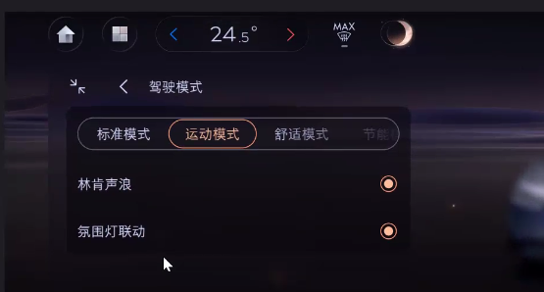

When EVSE work error, all interfaces will be not available, detail design refer to HMI UE.

## EVSE-SR-REQ-xxxxxx/EVSE Enhanced Memory

For vehicles which support, EVSE setting need to support enhanced memory and store enable or disable status for all driver profile, when profile changed, EVSE setting need to update status accordingly. Detail information need to confirm with enhanced memory owner.

## EVSE-SR-REQ-xxxxxx/EVSE Audio Path

EVS audio, generated by the EVSE algorithm, will be separate from and not affected by any audio processing steps which are applied to non-EVSE audio; such as volume, fader, balance, tone, vehicle EQ.

# Functional Requirements

## EVSE-SR-REQ-xxxxxx/EVSE Calibration File Structure

## EVSE-FUN-REQ-xxxxxx/EVSE Power Mode

### Functional Requirements

#### EVSE-SR-REQ-xxxxxx/EVSE power mode state definitions

EVSE Sleep:

EVSE Sleep State is defined as the state where the CAN bus is asleep and PS functionality is powered down.

EVSE Standby:

EVSE Standby State is defined as the state where the CAN bus is active, EVSE module is ready, but EVSE work condition not been met, HMIAudioMode=OFF or Ignition_Status =0x0(Unknow)/0x1(Off)/0xF(Invalid) .

EVSE Functional:

PS Functional State is defined as the state where the CAN bus is active, HMIAudioMode=ON and Ignition_Status =0x2(Acc)/0x4(Run)/0x8(Start) .

#### EVSE-SR-REQ-xxxxxx/Timing performance definition

EVSE component shall able to act upon HMIAudioMode=ON within 500ms from Can bus ready to transmit.

### Use Case

#### EVSE-UC-REQ-xxxxxx/Startup-With DSP

|  |  |
| --- | --- |
| **Actors** | Vehicle User |
| **Pre-conditions** | 1. HMIAudioMode is in OFF state.  2. Infotainment System comprises APIM and DSP |
| **Scenario Description** | 1. HMIAudioMode transition from OFF -> ON state.  2. NVH Management receives module status and channel status from DSP InfotainmentAudio_St2 and AudioAmplifier_Channel_St as ‘NormalOperation’ respectively.  3. Ignition_Status transition to Run. |
| **Post-conditions** | 1. Infotainment system shall be able to play EVSE audio when ignition_Status transition to Run. |
| **Exception Use Cases** | 1. ‘ErrorState_NoAudio’ status is received from DSP on ‘InfotainmentAudio_St2*’ and ‘*Channel_St’ signal. 2. APIM Error is detected() |
| **Notes** |  |

#### EVSE-UC-REQ-xxxxxx/Startup-Without DSP

|  |  |
| --- | --- |
| **Actors** | Vehicle User |
| **Pre-conditions** | 1. HMIAudioMode is in OFF state.  2. Infotainment System comprises APIM and DSP |
| **Scenario Description** | 1. HMIAudioMode transition from OFF -> ON state.  2. NVH Management receives module status and channel status from DSP InfotainmentAudio_St2 and AudioAmplifier_Channel_St as ‘NormalOperation’ respectively.  3. Ignition_Status transition to Run. |
| **Post-conditions** | 1. Infotainment system shall be able to play EVSE audio when ignition_Status transition to Run. |
| **Exception Use Cases** | 1. ‘ErrorState_NoAudio’ status is received from DSP on ‘InfotainmentAudio_St2*’ and ‘*Channel_St’ signal. 2. Other Error is detected |
| **Notes** |  |

### EVSE-SD-REQ-xxxxxx/EVSE Startup Sequence Diagram

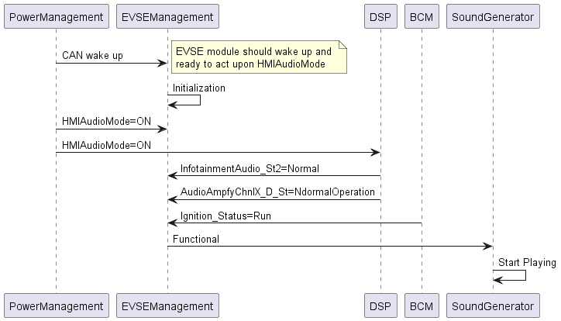

## EVSE-FUN-REQ-xxxxxx/EVSE Error Handling

### Functional Requirement

#### EVSE-SR-REQ-xxxxxx/EVSE Error Handling-Audio System Related Error -With DSP

For audio system with DSP, all EVSE speakers is connected to DSP and EVSE sound stream is transferred to DSP via A2B. Generally, 4 types of error is considerate, Any of this errors will result in EVSE module enter into fault status where stop EVSE play.

* Internal algorithm error, which means some error is occurred in sound generator internal which result in EVSE sound can’t be emitted;
* APIM Infotainment Audio error, which means some error is occurred in APIM component which is related with audio playing, like A2B error, LVI/OVI protection active, aDSP internal errors, ect.
* DSP Infotainment Audio error, which means some error is occurred in DSP component which is related with audio playing, like A2B error, LVI/OVI protection active, DSP internal errors, ect.
* DSP channel error, which means speakers connection fault which result in EVSE sound can’t be emitted.

#### EVSE-SR-REQ-xxxxxx/ EVSE Error Handling-Audio System Related Error -With DSP

For audio system without DSP, all EVSE speakers is connected to DSP and EVSE sound stream is transferred to DSP via A2B. Generally, 3 types of error is considerate, Any of this errors will result in EVSE module enter into fault status where stop EVSE play.

* Internal algorithm error, which means some error is occurred in sound generator internal which result in EVSE sound can’t be emitted;
* APIM Infotainment Audio error, which means some error is occurred in APIM component which is related with audio playing, like A2B error, LVI/OVI protection active, aDSP internal errors, ect.
* APIM channel error, which means speakers connection fault which result in EVSE sound can’t be emitted.

#### EVSE-SR-REQ-xxxxxx/EVSE Error Handling-Lost communication DTC

All Lost communication DTCs defined in Chapter ‘EVSE DTC’ will result in EVSE module enter into fault status where stop EVSE play.

#### EVSE-SR-REQ-xxxxxx/EVSE Error Handling-Invalid Calibration File DTC

All missing calibration file missing or corrupted DTC defined in Chapter ‘EVSE DTC’ will result in EVSE module enter into fault status where stop EVSE play.

#### EVSE-SR-REQ-xxxxxx/EVSE Error Check Related Signals

Signals set condition refer to following guidance:

* When there has APIM Infotainment Audio error, set ‘InfotainmentAudio_St’ as ErrorState_NoAudio;
* When there has DSP Infotainment Audio error , set ‘InfotainmentAudio_St2’ as ErrorState_NoAudio;
* When there has DSP channel error, set ‘AudioAmpfyChnlX_D_Stat’ as ‘NormalOperation’. Unused channels set to “Null”;
* When there has APIM channel error, set ‘AudioCtlChnlX_D_Stat’ as ‘ErrorState_NoAudio’. Unused channels set to “Null”;

### Use Case

#### EVSE-UC-REQ-xxxxxx/Internal error is received while playing EVSE

|  |  |
| --- | --- |
| **Actors** | Vehicle Occupant |
| **Pre-conditions** | Infotainment system is ON  EVSE is Enabled, and the EVSE audio is played through vehicle speakers |
| **Scenario Description** | Internal algorithm error is detected |
| **Post-conditions** | Active EVSE audio shall be stopped and not recovery until error disappear;  HMI setting display as ‘OperationInvalid’ (Detail refer to HMI UI/UE) |
| **Exception Use Cases** |  |
| **Notes** |  |

#### EVSE-UC-REQ-xxxxxx/APIM Infotainment error is received while playing EVSE

|  |  |
| --- | --- |
| **Actors** | Vehicle Occupant |
| **Pre-conditions** | Infotainment system is ON  EVSE is Enabled, and the EVSE audio is played through vehicle speakers |
| **Scenario Description** | APIM infotainment error is detected, like A2B error |
| **Post-conditions** | Send ‘InfotainmentAudio_St=ErrorState_NoAudio’ by APIM  Active EVSE audio shall be stopped and not recovery until error disappear;  HMI setting display as ‘OperationInvalid’ (Detail refer to HMI UI/UE) |
| **Exception Use Cases** |  |
| **Notes** | Applicable for other infotainment audio error |

#### EVSE-UC-REQ-xxxxxx/DSP Infotainment error is received while playing EVSE -With DSP

|  |  |
| --- | --- |
| **Actors** | Vehicle Occupant |
| **Pre-conditions** | Infotainment system is ON  EVSE is Enabled, and the EVSE audio is played through vehicle speakers |
| **Scenario Description** | DSP infotainment error is detected, like A2B error , DSP Send ‘InfotainmentAudio_St2=ErrorState_NoAudio’ by APIM |
| **Post-conditions** | Active EVSE audio shall be stopped and not recovery until error disappear;  HMI setting display as ‘OperationInvalid’ (Detail refer to HMI UI/UE) |
| **Exception Use Cases** |  |
| **Notes** | Applicable for other infotainment audio error |

#### EVSE-UC-REQ-xxxxxx/APIM channel error is received while playing EVSE -At least one channel used

|  |  |
| --- | --- |
| **Actors** | Vehicle Occupant |
| **Pre-conditions** | Infotainment system is ON  EVSE is Enabled, and the EVSE audio is played through vehicle speakers |
| **Scenario Description** | Speaker connected to APIM error |
| **Post-conditions** | Send ‘AudioCtlChnlX_D_Stat=ErrorState_NoAudio’by APIM  Active EVSE audio shall be stopped and not recovery until error disappear;  HMI setting display as ‘OperationInvalid’ (Detail refer to HMI UI/UE) |
| **Exception Use Cases** |  |
| **Notes** | Unused channels error not affect EVSE playing |

#### EVSE-UC-REQ-xxxxxx/DSP channel error is received while playing EVSE -At least one channel used

|  |  |
| --- | --- |
| **Actors** | Vehicle Occupant |
| **Pre-conditions** | Infotainment system is ON  EVSE is Enabled, and the EVSE audio is played through vehicle speakers |
| **Scenario Description** | Speaker connected to DSP error, receive ‘AudioAmpfyChnlX_D_Stat’=ErrorState_NoAudio’ |
| **Post-conditions** | Active EVSE audio shall be stopped and not recovery until error disappear;  HMI setting display as ‘OperationInvalid’ (Detail refer to HMI UI/UE) |
| **Exception Use Cases** |  |
| **Notes** | Unused channels error not affect EVSE playing |

#### EVSE-UC-REQ-xxxxxx/Lost communication is detected while playing EVSE

|  |  |
| --- | --- |
| **Actors** | Vehicle Occupant |
| **Pre-conditions** | Infotainment system is ON  EVSE is Enabled, and the EVSE audio is played through vehicle speakers |
| **Scenario Description** | Stop 0x420 |
| **Post-conditions** | Active EVSE audio shall be stopped and not recovery until error disappear;  HMI setting display as ‘OperationInvalid’ (Detail refer to HMI UI/UE) |
| **Exception Use Cases** |  |
| **Notes** | Apply to other lost communication DTCs |

#### EVSE-UC-REQ-xxxxxx/Calibration file is invalid while playing EVSE

|  |  |
| --- | --- |
| **Actors** | Vehicle Occupant |
| **Pre-conditions** | Infotainment system is ON  EVSE is Enabled, and the EVSE audio is played through vehicle speakers |
| **Scenario Description** | Erase calibration file |
| **Post-conditions** | Active EVSE audio shall be stopped and not recovery until error disappear;  HMI setting display as ‘OperationInvalid’ (Detail refer to HMI UI/UE) |
| **Exception Use Cases** |  |
| **Notes** |  |

## EVSE-FUN-REQ-xxxxxx/EVSE Enable/Disable by user

### EVSE-SR-REQ-xxxxxx/EVSE Audio Enable/Disable

PS Audio Components shall support to play PS audio along with the main audio source only when the PS audio is enabled through Infotainment Screen.

### Use Case

#### EVSE-UC-REQ-xxxxxx/User Enables Propulsion Sound Setting

|  |  |
| --- | --- |
| **Actors** | Vehicle User |
| **Pre-conditions** | Infotainment system is ON  EVSE Sound is Disabled (user HMI) |
| **Scenario Description** | User change EVSE sound setting to enabled |
| **Post-conditions** | EVSE sound is enabled  EVSE sound HMI is shown set to enabled. |
| **Exception Use Cases** | Error is detected |

#### EVSE-UC-REQ-xxxxxx/User Disables Propulsion Sound Setting

|  |  |
| --- | --- |
| **Actors** | Vehicle User |
| **Pre-conditions** | Infotainment System is ON  Propulsion Sound is Enabled (user HMI) |
| **Scenario Description** | User changes propulsion sound setting to disabled |
| **Post-conditions** | Propulsion sound is disabled  Propulsion sound HMI is shown set to disabled |
| **Exception Use Cases** | Error is detected |

### Activity Diagram

#### EVSE-ACT-REQ-xxxxxx/EVSE Sound Operation-With DSP

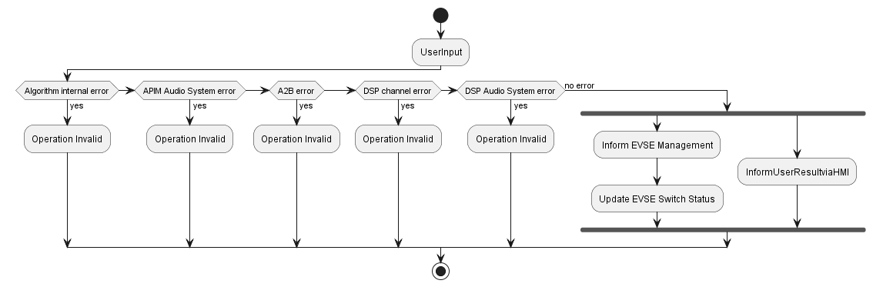

#### EVSE-ACT-REQ-xxxxxx/EVSE Sound Operation-Without DSP

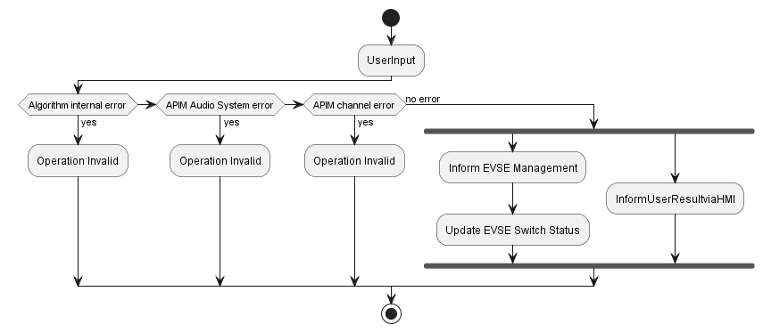

### Sequence Diagram

#### EVSE-SD-REQ-xxxxxx/EVSE Sound Operation-With DSP

#### EVSE-SD-REQ-xxxxxx/EVSE Sound Operation-Without DSP